GloboDiet
Data cleaning protocol: draft version
Dietary Exposure Assessment Group (DEX)
International Agency for Research on Cancer

GloboDiet
Data cleaning protocol: draft version
Dietary Exposure Assessment Group (DEX)
International Agency for Research on Cancer

Lyon, France, November 2014

Any queries on the circulation, reproduction or other use of the material should be directed to:

Dietary Exposure Assessment Group
International Agency for Research on Cancer
150, cours Albert Thomas
69372 Lyon Cedex 08, France
slimanin@iarc.fr

This copy of the guidelines is part of the GloboDiet methodology and is protected as pre-existing know-how (PEKH) during and after the current project. Proper acknowledgement of the use of the GloboDiet methodology, including the GloboDiet guidelines, should be made in any document, report or scientific paper resulting from the use of this methodology. Like all IARC products disseminated for educational and research purposes, the entire GloboDiet methodology enjoys copyright protection in accordance with the provisions of Protocol 2 of the Universal Copyright Convention. All rights are therefore reserved.


We acknowledge the financial support of the European Community under the ‘Europe AgainstCancer’ Programme (Grant No. SOC 96 200416) and the FP6 EFCOVAL project (Contract number: FOOD-CT-2006-022895). The EC is not liable for any use of the information contained herein.
We also thank all the contributors to this manual.
I. INTRODUCTION 2
II. GloboDiet interviews data cleaning during the data collection 3
2.1 quality controls builT in Globodiet 3
III. GloboDiet interviews data cleaning Using GloboDiet application 6
3.1 HaNdling note files 6
3.1.1. NOTES Concept 7
3.1.2. NOTES handling 8
IV. GloboDiet interview data cleaning in the exportED files 11
4.1 Data export 11
4.2 merging the exported files 11
4.3 quality controls in the merged file 12
V. Final data file 13
VI. ANNEXES 14
a) The Schofield (1985) equations for BMR are (in MJ/d): 14
Children under 3 years 14
3 to 10 years 14
10 to 18 years 14
Adults: 18 to 30 years 14
30 to 60 years 14
Over 60 years 14
b) The FAO/WHO/UNU (1986) equations for BMR are: 15
Children under 10 years 15
10 to 18 years 15
Adults: 18 to 30 years 15
30 to 60 years 15
Over 60 years 15

I. INTRODUCTION

In epidemiological research, errors occur in spite of careful study design, conduct, and implementation of error-prevention strategies. Data cleaning intends to identify and correct these errors or at least to minimize their impact on study results. Although error prevention strategies (including quality controls) can reduce many problems, they cannot eliminate them. Therefore data cleaning deals with data problems once they have occurred.
The data cleaning process includes different steps, involving repeated cycles of screening, diagnosing, and editing of suspected data abnormalities. Figure 1 shows these different steps, which can be initiated at different stages of a study. Many data errors are detected incidentally during study activities other than data cleaning and can be corrected during earlier stages of the study (e.g. during the fieldwork). However, ideally data cleaning is conducted via standardized and systematic procedures to detect errors by actively searching for them in a planned way.

Figure 1. A Data-Cleaning Framework presenting the different data cleaning steps
(Illustration: Giovanni Maki)

Data quality of dietary intake assessment methods depends on various elements that are present in all phases of data collection. The interview-administered 24-h dietary recall (24-HDR) GloboDiet has a series of controls (comprising all steps of fieldwork preparation, data collection and data management) to guarantee the quality of dietary data across countries. These quality controls are necessary in the following three study phases: 1) Before, 2) During, and 3) After the 24-HDR interview. Quality controls for consistency and harmonization are implemented before the fieldwork, during the preparation of the 70 parameter databases constituting a GloboDiet version (e.g., use of algorithms to convert foods from raw to cooked). During the interview, GloboDiet uses a cognitive, also named “stepwise”, approach to recall the information and includes controls for consistency (e.g., probing questions) and completeness of the collected data (e.g. possibility to create new foods/recipes that have to be updated). After the interview, a series of controls and corrections can be applied by coordinators/dieticians and data managers to further guarantee the data quality. For example, ‘note files’ that were created during the interview can be checked to correct the information initially provided, while the data managers can check for outliers in the final database.

This data cleaning protocol will focus on the quality controls and data cleaning processes that are performed in the 3rd phase of the study, starting when some 24-HDR interviews have been collected.

II. GloboDiet interview data cleaning during data collection

  - quality controls builT in GloboDiet

As mentioned before, different quality controls are present on the data collected or entered at the different stages of the GloboDiet dietary interview procedure. These quality control procedures are just warnings or aids that allow the interviewer and respondent to double-check the information entered in the GloboDiet program without blocking the on-going interview. The data/information for which a warning appears can either be confirmed or changed.

The following quality controls are built in GloboDiet:
- Controls on out-of-range values in the general information screens – Chapter IV.1 in the user manual (e.g. date of birth, weight, height); or during the quantification of foods and recipes – Chapter IV. 3.6.3 in the user manual;

- Controls on empty food consumption occasions (see chapter IV.2.2. in the user manual);

- Controls on easily forgotten foods attached to a given food consumption occasion, based on the check list mentioned in Chapter IV.2.2 of the user manual; or attached to a given quick list item or recipe, based on the probing questions, mentioned in Chapter IV.3.7 of the user manual;

- Controls on unknown and overflow quantities which are automatically captured in notes by the system during the interview. Before ending the interview, the UNKNOWN AND OVERFLOW QUANTITY SUMMARY screen listing the empty QLI and foods/recipes with missing (or overflow) quantities is displayed (Figure 1). This concerns all the reported foods/recipes for which the UNKNOWN quantification method has been used, those with quantity equal to zero and those exceeding the maxima values.

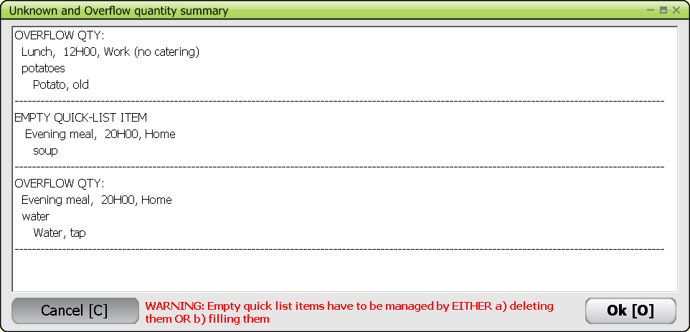

Figure 1: UNKNOWN AND OVERFLOW QUANTITY SUMMARY screen listing the empty QLI and foods/recipes with missing (or overflow) quantities.

Controls at the nutrient level (Figure 2). This last quality control of the dietary interview compares the estimated energy and macro-nutrient intakes with standard requirements calculated for the age and sex of the subject. The DIETARY INTERVIEW SUMMARY AND FINAL CHECKS screen displays general information on the subject (sex, age, weight …) and the calculated energy requirement. If the energy or one of the macronutrient values (proteins, fats, carbohydrates, alcohol) estimated from the 24-hour recall is out of the expected range, a warning TOO LOW or TOO HIGH is displayed. The energy intake (Figure 2) and the corresponding "as consumed" weights of foods and ingredients (Figure 3) are reported in four main categories (breakfast, lunch, dinner and other, plus total) to check whether a typing/selection error can explain out of range intake value. Overflow quantities are written in red to ease the visual control. The interviewer will visually check whether the calculated energy requirement is compatible with the reported intake and can still return to the Description/Quantification screen to check/change any data/information entered during the interview while still with the subject.
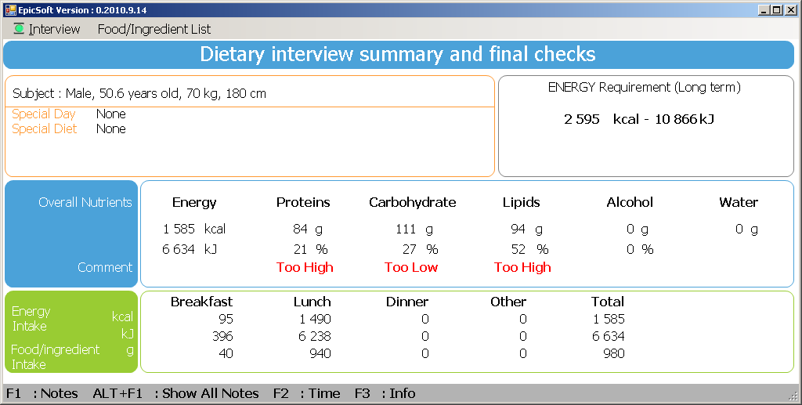

Figure 2: Final quality control screen on the nutrient level present the energy and macronutrient intakes in comparison with the energy requirement.

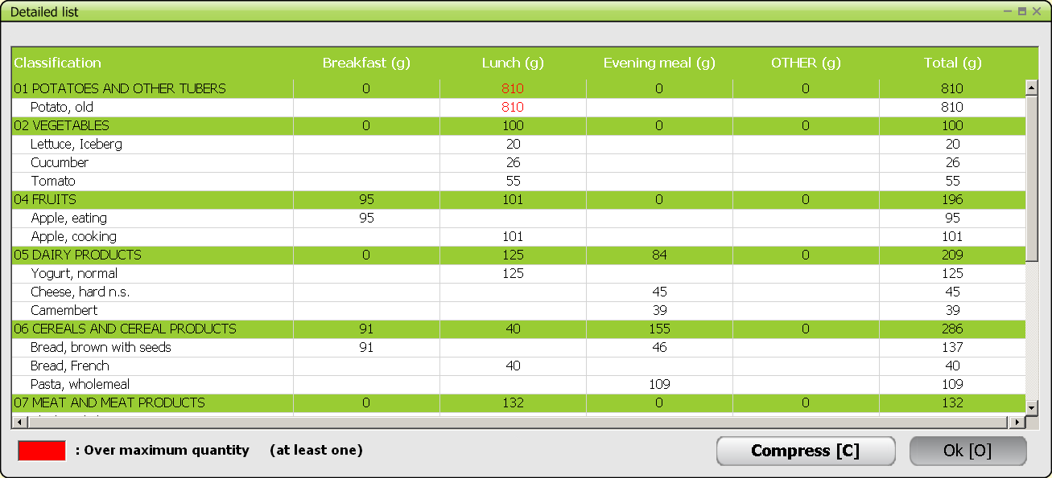

Figure 3: Detailed list of "as consumed" weights of foods and ingredients reported during the interview and their food groups, arranged by food consumption occasion.

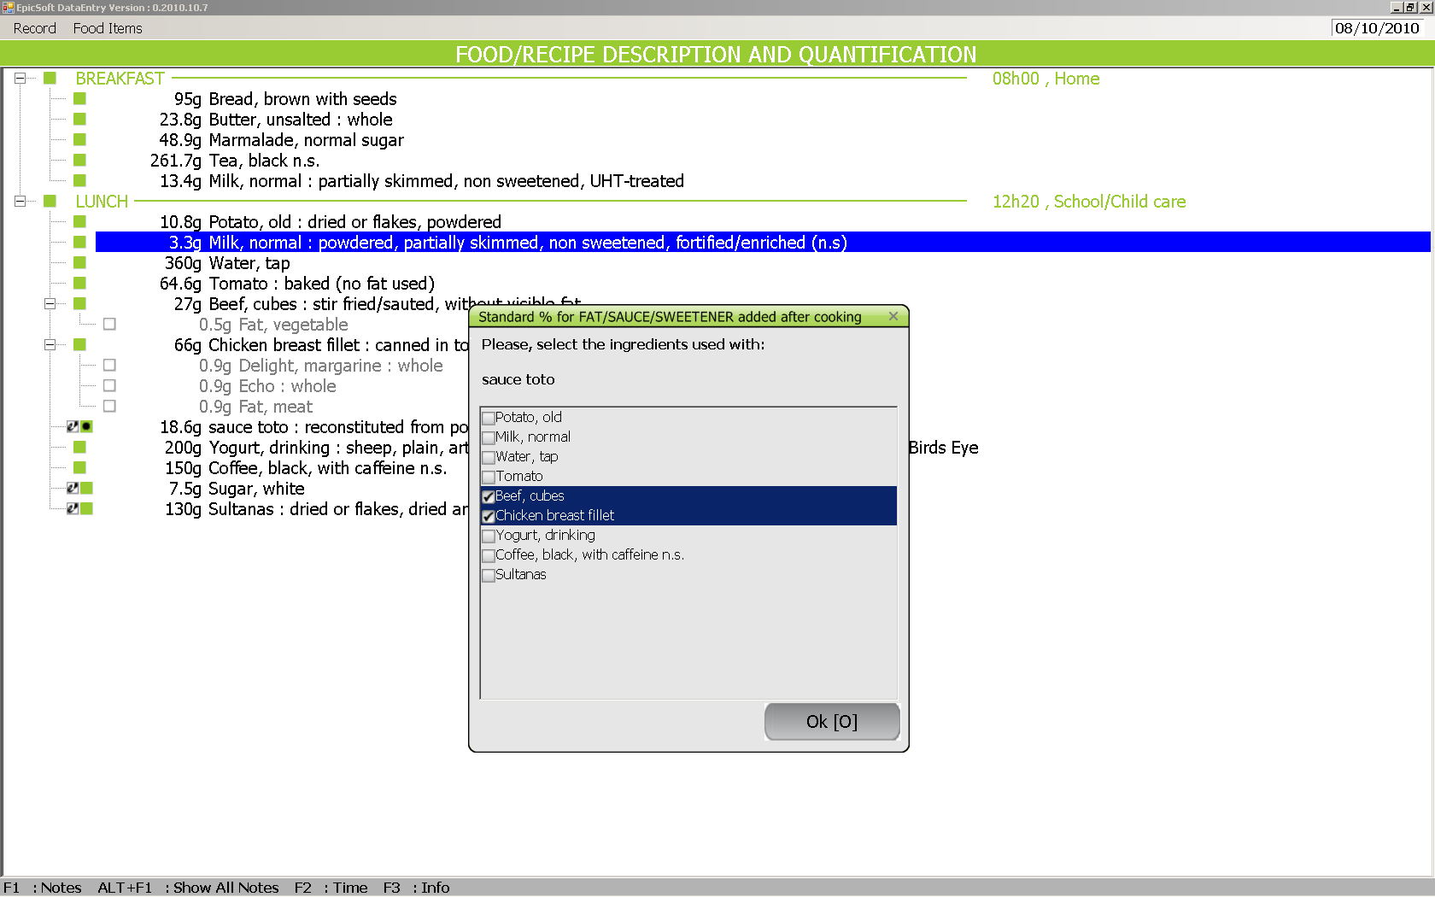
During the interview, different kinds of notes are generated in the GloboDiet interview, namely automatically generated notes (e.g. overflow or unknown quantity) and manually entered notes (e.g. when the interviewer wants to enter a comment or extra information that could be relevant for the person(s) in charge of the data handling & cleaning – function F1). An automatic note is always generated when a quality control or warning (e.g. out-of-range value) has been confirmed, while manual notes can be entered by the interviewer at any time during the interview. Notes are meant to be handled by the person(s) handling the GloboDiet interviews after data collection (during data cleaning process). The presence of notes attached to an item is flagged by an additional square in front of the green square (if food), or the blue square (if recipe).

The function ALT F1 (SHOW ALL NOTES) allows the interviewer to view all the notes at any time during the interview.

Although GloboDiet has been designed in such a way that most of the rules and criteria for conducting the interview are already pre-defined and can be easily updated and adapted (e.g. list of foods or recipes, type and number of questions to be systematically asked in order to describe foods, quantification methods to estimate food or recipe portion sizes), the role of the interviewers remains essential to ensure the quality and the standardisation of the data collection. It is important that, before the interview, the interviewer is well acquainted with GloboDiet and the related databases (e.g. food list, food or recipe classification systems, picture book,..) and that the rules pre-defined in the software, indicated in the user manual and annex documents or mentioned during the local training course are strictly followed. The interviewers should know that handling the notes after the data collection is time consuming and should therefore try to minimize the number of notes entered or generated. For instance Empty Quick list items (QLI) should be removed before going to the following step: choose Cancel and either delete them or add item(s) under them. Furthermore, the interviewers should be advised on the most optimal/efficient way to enter notes during the interview. Locally, regular meetings gathering the interviewers and/or internal leaflets can help limit the number of notes.

III. GloboDiet interviews data cleaning Using GloboDiet application

  - HaNdling note files

Once a set of interviews has been collected, the interviewers have to export the collected GloboDiet interviews using the Export GloboDiet function. This export procedure needs to be done regularly. The following files are generated during the export:
- InterviewSetName.XML: this contains all the information; this format is used by GloboDiet application to import interview sets
- InterviewSetName_INTGI.CSV: this contains only general information on subjects and on recall/record
- InterviewSetName.INTERV.CSV: this contains only reported foods/recipes/ingredients/dietary supplements with detailed consumption descriptions
- InterviewSetName.INTER_QT.CSV: this contains only two specific quantification methods, namely photo and shape methods
- InterviewSetName.INTNUT.CSV: this contains only energy and macronutrient intakes per reported food (the one used for checks in the system after the recall)
- InterviewSetName.NOTES.CSV: this contains only reported notes generated during the interview/data entry
- InterviewSetName BAK: this contains all the information; this format is used by GloboDiet application to restore interview sets in case of PC scratch

All these files have to be sent to the coordinator/person in charge of the interview data handling and cleaning.
- Interview Data handling:
First, all the received files have to be stored and centralized by the coordinator. Then the received NOTES files have to be merged in one file (e.g. using Excel).
See Annex 1: How to open a csv-file with Excel
See Annex 2: Merge csv-files
- Note handling to prepare the data cleaning:
Then, using the unique NOTE Excel file, the coordinator can comment all the received notes in a systematic way by:
  - Adding information in a new comment column and
  - Changing the Note Status (e.g. moving from “New” to “nothing to do”).
Guidelines for handling the GloboDiet notes are given in the sections below.

3.1.1. NOTES Concept

a) Notes attached to an Item

Notes are generated/entered during the GloboDiet interview and stored as data available in the interviews database. A note is always attached to an item:
- General Notes attached directly to a Subject
- Specific Notes attached to a:
FCO (Meal)
Quick list item (QLI)
Food/fat
Recipe
Ingredient
Supplement

"Item Type" indicates which item the note is attached to and the "Note Type" the reason the note was created. These fields are stored in the database.

An overview of the different note types available is given in Table 2.

b) Note Status

A Status is attached to each note. It will be used to indicate the current state of the note and the actions to be taken for the particular item. Each status will have an attribute attached called S_Hide indicating if the note having this status must or must not be displayed.
The note’s status (values and description) is project dependent except for the modality “New” (coded 00) that is automatically attributed at the note creation by GloboDiet.

Table 1. Example of a note status list, including descriptions and actions to be taken

Value | Description | S_Hide | Action required
00 | New (default) | No hide | Original status for all notes note should be read and status should be changed after reading/handling the note
01 | Ongoing | No hide | Note has been read and the action to be taken has been described in the note the action needs to be executed
03 | Action approved by coordinator | No hide | Action described in note and approved by coordinator should be executed
02 | No action needed/Ignore | Hide | Final status no action needed
04 | To be discussed | No hide | Internal discussion needed to find a solution
05 | Check in shops | No hide | Check in shop to find the data
06 | Action after GloboDiet update | No hide | Cleaning needed in Edit interview mode
07 | Missing to be filled later | No hide | Search/cleaning/further action required
99 | Action done | Hide | Final status no action needed

3.1.2. NOTES handling

Notes may be handled via two different scenarios:

- Notes to be handled in GloboDiet edit interview mode:
- Import in GloboDiet the sets of interviews that include interviews that need to be updated.
- Handle the interview in GloboDiet edit interview mode according to the actions specified in the note.

- Notes to be handled in GloboDiet edit interview mode after the update of GloboDiet database via maintenance process:
- Update the concerning GloboDiet tables via the database maintenance process;
- Prepare a new/updated GloboDiet database version;
- Install this new GloboDiet database version in GloboDiet application;
- Import in GloboDiet, the sets of interviews that include interviews that need to be updated.
- Handle the interviews in GloboDiet edit interview mode according to the actions specified in the note.

Once a set of interviews has been updated, the coordinator has to re-generate the csv-files (using the interview backup process) in order to start the descriptive statistical analyses.
Whenever some databases have been updated and a new GloboDiet database version was created, a RECOMPUTE is done automatically during the data export & backup.

The following table will show the possible notes available and how to handle these notes. The above two scenarios will be indicated in the table as follows:
- GD: using GloboDiet in edit interview mode.
- MS: using the database maintenance process to update the databases prior to updating the interviews via GloboDiet edit interview mode.

Table 2. Possible Note types, including automatically (A) generated notes and manually (M) entered notes

ITEM  TYPE | NOTE TYPE | TYPE  CODE | Comments | Prio-rity | A/M | Note handling
Subject | General | G |  | 2 | M | Handling depends on the content of the comment
 | Special diet | G_DT | Note for “Other” field for special diet | 3 | A | Can be used to update the list of special diets in maintenance and settings (MS) OR can be reallocated to an existing special diet category (GD)
 | Special day | G_DY | Note for “Other” field for special day | 3 | A | Can be used to update the list of special day in maintenance and settings (MS) OR can be reallocated to an existing special day category (GD)
FCO | Specific | SPE | If a Note already exists, the type code is not changed. | 2 | M | Handling depends on the content of the comment
QLI | Specific | SPE | If a Note already exists, the type code is not changed. | 2 | M | Handling depends on the content of the comment
 | Empty | EMP |  | 3 | A | Can be deleted together with the QLI (?) in the interviews using GloboDiet edit interview mode (GD)
FOOD | New food | NEW_F | Message “New food” | 1 | A | Can be used to update the food list in the maintenance process (MS) OR can be reallocated to an existing food item (GD)
 | Specific | SPE | If a Note already exists, the type code is not changed. | 2 | M | Handling depends on the content of the comment
 | Unknown quantity | UNK | Message “Unknown quantity”.  If a Note already exists, the type code is not changed. | 2 | A | Depends on rules/strategies defined at project level (e.g. replace missing values by mean or median values) (GD)
 | Null quantity | NULL | Message “Null quantity”.  If a Note already exists, the type code is not changed. | 2 | A | Depends on rules defined at project level (GD)
 | Overflow quantity | OVER | Message “Overflow quantity”.  If a Note already exists, the type code is not changed. | 3 | A | Has been checked by respondent/dietician during interview quantity should not be changed. However, update of food max database may be needed (MS)

ITEM  TYPE | NOTE TYPE | TYPE  CODE | Comments | Prio-rity | A/M | Note handling
RECIPE | New recipe | NEW_R | Message “New recipe” | 1 | A | Can be used to update the recipe list in the maintenance process (MS) OR can be reallocated to an existing recipe item (GD)
 | Strictly commercial recipe | COM | Message “Commercial recipe” | 3 | A | Warning no action needed. However, update of Commercial recipes list in databases may be needed (MS) with regards to brands
 | Open unknown recipe | I_ADD | Message “Open recipe: added ingredient” | 1 | A | Recipe needs to be checked/updated in GloboDiet edit interview mode (GD) especially when the added ingredient quantity is > 5 % of the whole recipe portion (with R_MODIF=2)
 | Open unknown recipe | I_DEL | Message “Open recipe: deleted ingredient” | 1 | A | Recipe needs to be checked/updated in GloboDiet edit interview mode (GD) especially when the deleted ingredient quantity is > 5 % of the whole recipe portion (with R_MODIF=2)
 | Specific | SPE | If a Note already exists, the type code is not changed. | 2 | M | Handling depends on the content of the comment
 | Unknown quantity | UNK | Message “Unknown quantity”.  If a Note already exists, the type code is not changed. | 2 | A | Depends on rules/strategies defined at project level (e.g. replace missing values by mean or median values) (GD)
 | Null quantity | NULL | Message “Null quantity”.  If a Note already exists, the type code is not changed. | 2 | A | Depends on rules defined at project level (GD)
 | Overflow quantity | OVER | Message “Overflow quantity”.  If a Note already exists, the type code is not changed. | 3 | A | Has been checked by respondent/dietician during interview quantity should not be changed. However, update of food max database may be needed (MS)

ITEM  TYPE | NOTE TYPE | TYPE  CODE | Comments | Prio-rity | A/M | Note handling
INGRE-DIENT | New food | NEW_F | Message “New food” | 1 | A | Can be used to update the food list in the maintenance process (MS) OR can be reallocated to an existing food item (GD)
 | Specific | SPE | If a Note already exists the type code is not changed. | 2 | M | Handling depends on the content of the comment
 | Unknown quantity | UNK | Message “Unknown quantity”.  If a Note already exists, the type code is not changed. | 2 | A | Depends on rules/strategies defined at project level (e.g. replace missing values by mean or median values) (GD)
 | Null quantity | NULL | Message “Null quantity” .  If a Note already exists, the type code is not changed. | 2 | A | Depends on rules defined at project level (GD)
SUPPLE-MENT | New Supplement | NEW_S | Message “New supplement” | 1 | A | Can be used to update the supplement list in the maintenance process (MS) OR can be reallocated to an existing dietary supplement item (GD)
 | Specific | SPE | If a Note already exists, the type code is not changed. | 2 | M | Handling depends on the content of the comment
 | Unknown quantity | UNK | Message “Unknown quantity”.  If a Note already exists, the type code is not changed. | 2 | A | Depends on rules defined at project level (GD)
 | Other descriptor of supplement | F_xx | XX stands for the supplement facet number. See Table DS_Facet. Examples :  F_01= other source, F_03= other place… | 3 | A | Can be used to update the list of supplement descriptors in maintenance and settings (MS) OR can be reallocated to an existing supplement descriptor (GD)
A: automatically generated notes Priority: 1=highest / 2=medium / 3=lowest
M: manually entered notes

To summarize the management of the different Note types, they are listed below according to a proposal of order of priority:

- Priority = 1 To be checked and modified in the interviews
  - NEW_F New foods can be reallocated to an existing food item (GD) OR can be used to update the food list (MS) followed by interview updates (GD)
  - NEW_R New recipes can be reallocated to an existing recipe item (GD) OR can be used to update the recipe list (MS) followed by interview updates (GD)
  - NEW_S New supplements can be reallocated to an existing supplements item (GD) OR can be used to update the supplements list (MS) followed by interview updates (GD)
  - I_ADD Addition of ingredients in unknown recipe that needs to be checked/updated (GD) especially when the added ingredient quantity is > 5 % of the whole recipe portion (with R_MODIF=2)
  - I_DEL Suppression of ingredients in unknown recipe that needs to be checked/updated (GD) especially when the deleted ingredient quantity is > 5 % of the whole recipe portion (with R_MODIF=2)

- Priority = 2 To be checked, (usually) with or without changes in the interviews with GloboDiet (depending of the comment) and also with possible update using external software (e.g. SAS, Stata, SPSS…):
  - SPE Specific notes have to be read and handled depending on the comment
  - G General notes linked to the subject have to be read and handled depending on the comment
  - NULL Null quantities for foods, recipes, ingredients can be reviewed depending on the project rules (GD).
  - UNK Unknown quantities for foods, recipes, ingredients & supplements can be reviewed depending on the project rules (GD)

- Priority = 3 To be checked, (usually) without changes in the interviews and with possible update of GloboDiet database for the future interviews:
  - OVER Overflow quantity for foods & recipes have not to be changed because already checked during interview but can be used to update the food max file (MS)
  - G_DT New Special Diet value - may be used to improve the special diet list (MS)
  - G_DY New Special day value - may be used to improve the special day list (MS)
  - F_xx New supplement descriptor - may be used to improve the supplement descriptor list (MS)
  - COM Recipe selected as Commercial - may be used to improve the commercial recipe list (MS)
  - EMP Empty quick list items. The number of EMP code must be small (training issue) and can be used to check the completeness per interviewers.

REMINDER: Make sure to save a version of the XML file, the BAK file and the 5 CSV files at each step.
The communication between the interviewers and the coordinator(s) has to be done using the XML-files (and CSV-files if needed).

IV. GloboDiet interview data cleaning in the exportED files

  - Data export

For guidance in the data export we refer to the Appendix 6 Guidelines for export data in GloboDiet.

  - merging the exported files

The following 5 csv-files are generated during the data backup and export:

- InterviewSetName_INTGI_date.CSV: general information on subject and on recall/record
- InterviewSetName.INTERV_date.CSV: reported foods/recipes/ingredients/supplements with detailed consumption descriptions
- InterviewSetName.INTER_QT_date.CSV: two specific quantification methods, namely photo and shape methods
- InterviewSetName.INTNUT_date.CSV: energy and macronutrient intakes per reported food (the one used for checks in the system after the recall)
- InterviewSetName.NOTES_date.CSV: reported notes generated during the interview/data entry

Although the most important 24-HDR information is included in the INTERV file, the information included in the INTGI and the INTNUT files may be relevant for the further data cleaning procedures performed after the data export and those left in the NOTES and included in INTERV_QT files generally do not contribute to these data cleaning processes.

The most efficient way in performing the data cleaning after the data export is to merge all the variables included in the INTERV, INTGI and INTNUT files in one single data file. Such a merge procedure can be executed automatically via statistical software packages such as SPSS, SAS, STATA or R (R is freely available/downloadable via the internet).
See Appendix 7 Example of SAS program to read GloboDiet export csv-files.

It should be underlined that the nutrient information included in INTNUT should not be used as final nutrient intake information (for analytical purposes), but only as quality control information! When aiming at analysing nutrient intake information, an extra merge should be performed with accurate food composition tables. This linking procedure between the food consumption data file derived from GloboDiet and the food composition tables is NOT handled in this data cleaning protocol.

  - quality controls in the merged file

Because of the different quality control procedures included before and during the data collection phase, the number of remaining errors in the exported data files is importantly reduced. Nevertheless, some basic quality control procedures are still recommended before the data are used for statistical analyses.

The basic quality control procedures that are recommended are:

- Checks in data processing: during food linkage/merging (e.g. ID-numbers)
- All New foods have been handled no New foods anymore in the database
- All New unknown recipes have been handled no New unknown recipes anymore in the database
- Check distribution of the consumed quantities by GloboDiet food classification at group, subgroup and sub-subgroup levels (mean, SD, min, percentiles, max…)
- Ten lowest and Ten highest nutrient intakes of the nutrients of interest (e.g. energy & macronutrients) should be evaluated. Strange values should be checked with original interview files.
- Number of interviews (1, 2, etc…) per subject
- Distribution of interviews over the week
- Duration of the interviews
- Subject characteristics (gender, socioeconomic, age)
- Number of items per interview
- Number of days between the interviews
- Number of errors with regard to design/planning
- Energy ratio (energy intake vs required)
- Energy ratio (Goldberg & Black) see annex 3

Implausible values and mistakes that are discovered during these final quality controls can be corrected in this merged data file via different procedures:
- Directly in the data file (not recommended as the changes cannot be retrieved afterwards);
- Corrections are coded via syntaxes/scripts in statistical software packages (recommended).

The handling procedures for implausible values are study-specific and should be written/published in a study-specific data cleaning protocol (e.g. how are interviews below the Goldberg cut-off being handled?).

In case systematic errors would be detected (e.g. a mistake in coefficients/percentages being applied), it would be recommended to perform these corrections in GloboDiet application before the data export rather than via statistical software packages after the export to make sure that all the related factors are applied in a standardized and correct way.

V. Final data file

The final data file for statistical analyses is obtained when the quality controls and correction procedures described under 4.3 have been applied. It is noteworthy that this final data file can still include interviews that are considered as implausible usual dietary intakes (e.g. interviews below the Goldberg cut-off, respondents with fewer interviews than foreseen in the study protocol). However, the way in which these respondents or interview should be handled in the statistical analyses should be written/published in a statistical analyses protocol and might depend on the aim of the statistical analyses to be performed (e.g. descriptive versus analytical).

VI. ANNEXES

Annex 1: How to open a csv-file with Excel

We can always open a CSV-file with excel by clicking directly on the file but, in this case, some format information can be lost as well as special characters (e.g. accents…).

It is for this reason that we recommend to use the functions of Excel called “Data” & “From Text”:

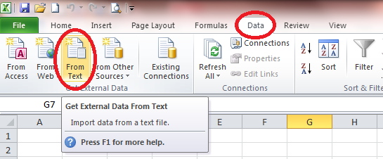

Once you have selected this function, Excel asks you to select a CSV-file in your folder.
For example, here, the Notes file dated from 30 April 2014 of interviewer called Marina:
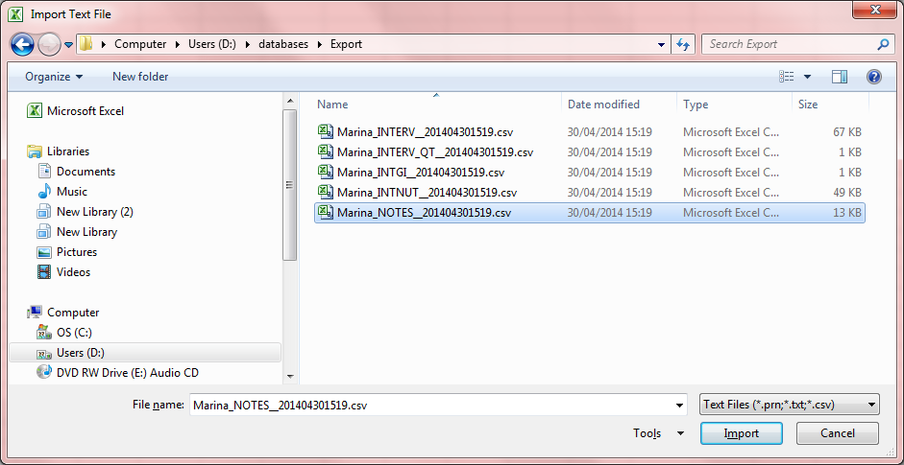

Then Excel asks you to select a data type between 2; Delimited or Fixed and also to select a File origin.
For the GloboDiet CSV-files, you have to select:
- Delimited as data type
- Unicode (UTF-8) as origin (strongly recommended)
You can then select the “Next” button.
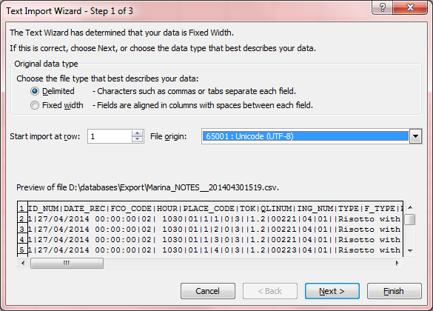

The next pop-up is related to the file format. You have to define the delimiter and the format of each column.
For the GloboDiet CSV-files, you have to select ‘Other’ and type the pipe (‘|’) character as delimiter.
Then, you can select the “Next” button.

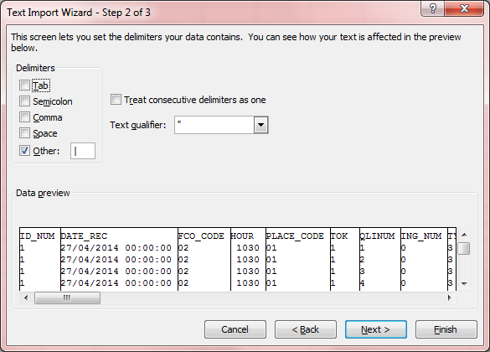

For each column, the format has to be specified. You can select all the columns at once by clicking on the first column, then move to the last one and while holding theShift key + click on the last column with the mouse at the same time.
For the Notes file, you can declare all the columns as Text except for the CONS_QTY one that is General format.
- See guideline Appendix 7 Example_SAS_programs_GloboDiet_Export.docx to transform the 5 CSV- files in SAS databases.

- See the document Appendix 6 – Formats of exported data.doc to have the detailed formats of all the GloboDiet Export CSV-files as the possible values (and labels) for each column.

Then, you can select the “Finish” button.
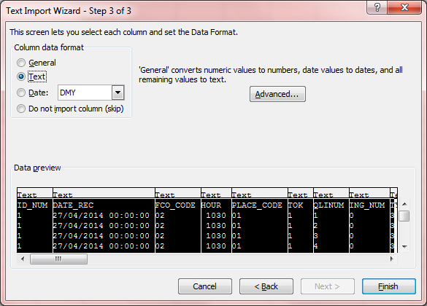
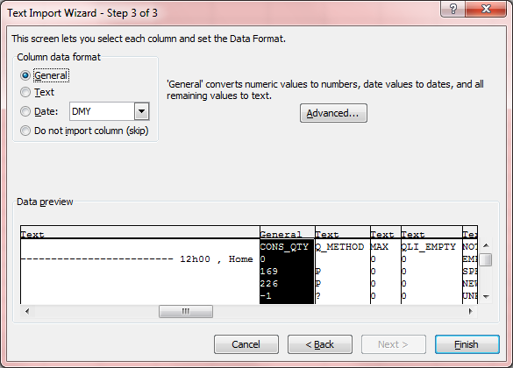

The last question is related to where the data will be placed in the worksheet and usually the cell A1 (top – left) is pre-selected. By clicking on OK button, the data are displayed in the Excel sheet.

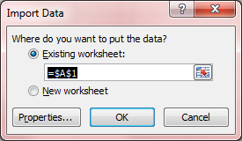

Example with the Notes file:
The first few columns of the Notes file worksheet are specify the subject codes (column A in blue below) & interview dates (column B below), followed by information on the reported items such as the FCO (column C below), Type (column I below) and item label (column P in blue below).

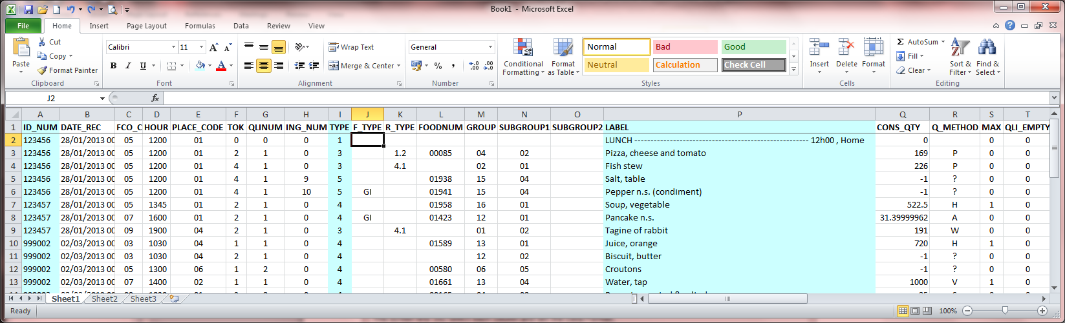

To the right of the worksheet, you can see the information related to the reported Notes such as the code for the note type, status, the reported comments (column W below) and the date of the last comments entered (column X below).

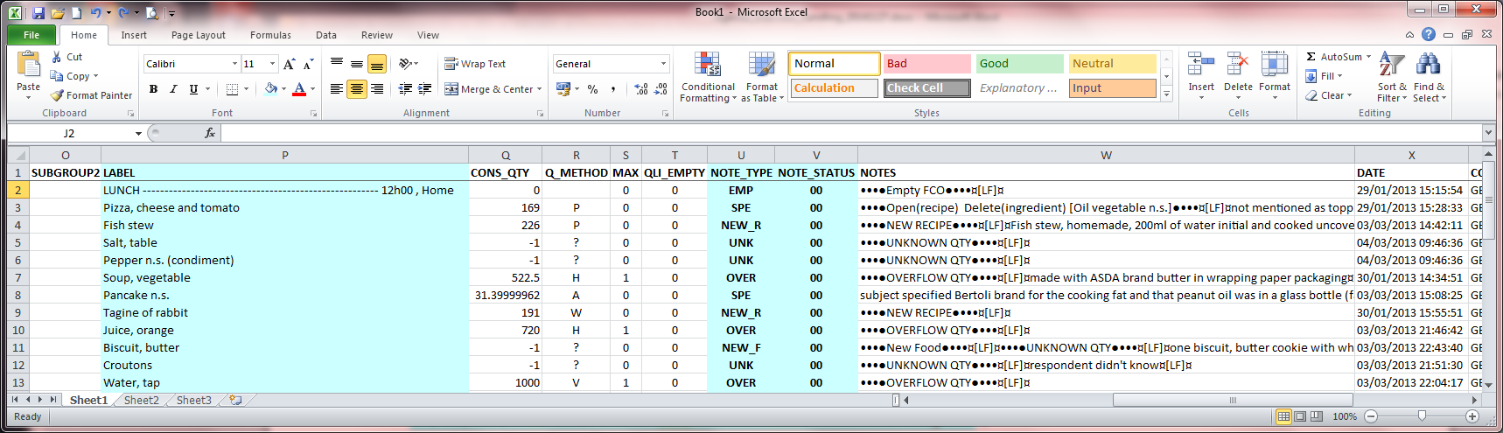

Note: the characters “¤[LF]¤” in the Notes column, is the paragraph mark used by GloboDiet application.

4.3 Formats of the GloboDiet exported CSV-files
- See guideline Appendix 6 Export_guideline_v4.docx to have the format of the 5 generated CSV-files

4.4 Example on how to import the GloboDiet CSV-files using SAS program
- See guideline Appendix 7 Example_SAS_programs_GloboDiet_Export.docx to transform the 5 CSV- files in SAS databases.

Annex 2: How to merge the exported csv-files

The GloboDiet export generates the 5 following csv-files:
- InterviewSetName_INTGI_date.CSV: general information on subject and on recall/record
- InterviewSetName_INTERV_date.CSV: reported foods/recipes/ingredients/supplements with detailed consumption descriptions
- InterviewSetName_INTER_QT_date.CSV: two specific quantification methods, namely photo and shape methods
- InterviewSetName_INTNUT_date.CSV: energy and macronutrient intakes per reported food (the one used for checks in the system after the recall)
- InterviewSetName_NOTES_date.CSV: reported notes generated during the interview/data entry
Each interviewer has to export and send the collected data to the coordinator(s) .The coordinator can need to merge them before managing them (e.g. for the received Notes.csv files).
A way to do is to use a bat-file where specific commands are used. You can find here 2 examples on how to prepare this Merge_csv_file.bat.

Some explanations on the content of the bat-file:
- A line starting with REM is a comment line
- The first commands are to define the folder where the csv-files are and have to be revised according to your needs (highlighted in blue).
- The last commands are to merge the csv-files in one
- The merged file should be a csv-file too
- The string highlighted in blue can be adapted to you needs (e.g. folder name, merged file name)

Preparation of the bat-file:
- Open Notepad application
- Select the commands of the first or second example from Start to the End lines, copy and paste them in Notepad
- Adapt the commands to your needs
- Save the notepad file choosing .bat as extension (e.g. merge_csv.bat)

Run of the bat-file
- To run the bat-file, you just have to double click on it.
- A black pop-up is opened where the merged files are listed after each Copy command.
- To close this pop-up, you can type exit or use the cross at the top right of the window.
- If the merged file already exists and you run again the bat-file, the merged file will be replaced by the new one so do not forget to save it in another folder.

Example 1: the merged csv-files are put in the same folder as the other csv-files

REM Start:
REM Merge of CSV-FILES – Generated files available in the same folder

REM Move to the folder

D:
cd d:\GD_data\Marina\

REM Merge of the csv-files in 5 main ones

REM Use of 'COPY' command
REM - the star is used to select all the csv-files containing the string “INTGI__201”
REM - the merged file names are defined in the right of the command (e.g. INTGI_2014.csv)
REM - in this example, the 5 new created files will be stored in the same folder
REM as all the csv-ones and here in d:\GD_data\Marina

COPY *INTGI__201*.csv INTGI_2014.csv
COPY *INTERV__201*.csv INTERV_2014.csv
COPY *INTERV_QT__201*.csv INTERV_QT_2014.csv
COPY *INTNUT__201*.csv INTNUT_2014.csv
COPY *NOTES__201*.csv NOTES_2014.csv

cmd
REM The end

Example 2: the merged csv-files are put in a sub-folder called Merge that is created during the process

REM Start
REM Merge of CSV-FILES put in Merge sub-folder

D:
cd d:\GD_data\Marina\

REM Creation of a sub-folder called Merge (e.g. d:\GD_data\Marina\Merge)

md Merge

REM Merge of the csv-files in 5 main ones

REM Use of 'COPY' command
REM - the star * is used to select all the csv-files containing the string “INTGI__201”
REM - the merged file names are defined in the right of the command (e.g. INTGI_2014.csv)
REM - in this example, the new 5 created files will be stored in the already created folder
REM d:\GD_databases\Marina\Merge

COPY *INTGI__201*.csv Merge\INTGI_2014.csv
COPY *INTERV__201*.csv Merge\INTERV_2014.csv
COPY *INTERV_QT__201*.csv Merge\INTERV_QT_2014.csv
COPY *INTNUT__201*.csv Merge\INTNUT_2014.csv
COPY *NOTES__201*.csv Merge\NOTES_2014.csv

REM Remark: in place of the ‘Merge\’ folder, you can also specify the entire folder name as
REM COPY *INTGI__201*.csv \GD_data\Marina\Merge\INTGI_2014.csv

cmd
REM The end

Annex 3: Energy requirement, Goldberg cut-off and Macro-nutrient checks

ENERGY REQUIREMENT ALGORITHMS

The energy requirements are calculated using the following equation:

ENERGY REQUIREMENT = BMR * PAL

To compute the BMR values, the 2 following approaches are available in GloboDiet:

a) The Schofield (1985) equations for BMR (in MJ/d) are:

Height is expressed in metres
Weight is expressed in kg

Children under 3 years
Boys BMR: 0.0007 weight + 6.349 height – 2.584
Girls BMR: 0.068 weight + 4.281 height – 1.730

3 to 10 years
Boys BMR: 0.082 weight + 0.545 height – 1.736
Girls BMR: 0.071 weight + 0.677 height – 1.553

10 to 18 years
Boys BMR: 0.068 weight + 0.574 height + 2.157
Girls BMR: 0.035 weight + 1.948 height + 0.837

Adults: 18 to 30 years
Boys BMR: 0.063 weight – 0.042 height + 2.953
Girls BMR: 0.057 weight + 1.184 height + 0.411

30 to 60 years
Boys BMR: 0.048 weight – 0.011 height + 3.670
Girls BMR: 0.034 weight + 0.006 height + 3.530

Over 60 years
Boys BMR: 0.038 weight + 4.068 height – 3.491
Girls BMR: 0.033 weight + 1.917 height + 0.074

b) The FAO/WHO/UNU (1986) equations for BMR are:

Height is expressed in metres
Weight is expressed in kg

Children under 10 years
Not available

10 to 18 years
Boys BMR (kJ): 69.4 weight + 322.2 height + 2392
Boys BMR (kcal): 16.6 weight + 77 height + 572

Girls BMR (kJ): 30.9 weight + 2016.6 height + 907
Girls BMR (kcal): 7.4 weight + 482 height + 217

Adults: 18 to 30 years
Boys BMR (kJ): 64.4 weight – 113.0 height + 3000
Boys BMR (kcal): 15.4 weight - 27 height + 717

Girls BMR (kJ): 55.6 weight + 1397.4 height + 146
Girls BMR (kcal): 13.3 weight + 334 height + 35

30 to 60 years
Boys BMR (kJ): 47.2 weight + 66.9 height + 3769
Boys BMR (kcal): 11.3 weight + 16 height + 901

Girls BMR (kJ): 36.4 weight - 104.6 height + 3619
Girls BMR (kcal): 8.7 weight - 25 height + 865

Over 60 years
Boys BMR (kJ): 36.8 weight + 4719.5 height - 4481
Boys BMR (kcal): 8.8 weight + 1128 height - 1071

Girls BMR (kJ): 38.5 weight + 2665.2 height - 1264
Girls BMR (kcal): 9.2 weight + 637 height - 302

GOLDBERG CUT-OFFS

(Black 2000)

To determine whether a given mean value of EI_{rep}:BMR in n subjects is acceptable, the following must be satisfied:

Under-reporting (1): EI_{rep}:BMR > PAL x exp s.d._{min} x (S/100) / √n

Over-reporting (2): EI_{rep}:BMR < PAL x exp s.d._{max} x (S/100) / √n

With PAL = mean PAL for population under study
s.d._{min} = -2 for the 95% (-3 for 99%) lower confidence limit
s.d._{max} = +2 for the 95% (+3 for 99%) upper confidence limit
n = number of subjects in the study
S = factor that takes account of the variation in intake, BMR and energy requirements, and is given by S = ((CV²_{wEI} / d) + CV²_{wB} + CV²_{tP})^{1/2}
Where CV_{wEI} = within-subject coefficient of variation in energy intake,
d = number of days assessed,
CV_{wB} = coefficient of variation of repeated BMR measurements or the precision of estimated compared with measured BMR,
and CV_{tP} = the total variation in PAL.

In order to maximize the sensitivity and specificity of the cut-off, each element of the equation should be substituted with values appropriate for the specific study being evaluated. The evaluation of individual intake is a special case of the Goldberg cut-off in which n=1.

Although formula (2), described above can be used for calculating the upper confidence limit, this formula should only be used when the activity of the population is known, such that it is possible to assign an appropriate mean PAL. For the lower limit, the cut-off was calculated, using the PAL for sedentary lifestyle (= 1.55).

For GloboDiet, the following values need to be applied in the above formulas:

CvWei 23
CVwb 8.5
CVtP 15
d 1
n 1
sd -2

As PAL factor for adults, we usually take 1.55 for adults.

For children Sichert-Hellert et al. (1998) used levels of light physical activity for children:
PAL for children 1-5 y = 1.45
PAL for children 6-13 y = 1.55
PAL for children 14-18 y = 1.60

On page 90 from the document “Human energy requirements: Report of a Joint FAO/WHO/UNU Expert consultation, it is recommended to calculate the ideal weight for a given height corresponding to a BMI of 22.0!

GOLDBERG CUT-OFFS: Calculation for GloboDiet

S = [ 23² /1 + 8.5² + 15² ]^{1/2} = [826.25]^{1/2} = √826.25 = 28.7445647

Under-reporting for the 95%:
EI_{rep}:BMR > PAL x exp { s.d._{min} x (S/100) / √n }
PAL x exp { -2 x [(√826.25)/100] / 1 }
PAL x exp {-0.57489129}
PAL x 0.562766041

For adult: PAL = 1.55
EI_{rep}:BMR > 1.55 x 0.562766041

For children 1-5 years: PAL = 1.45
EI_{rep}:BMR > 1.45 x 0.562766041

For children 6-13 years: PAL = 1.55
EI_{rep}:BMR > 1.55 x 0.562766041

For children 14-18 years: PAL = 1.60
EI_{rep}:BMR > 1.60 x 0.562766041

Over-reporting for the 95%:
EI_{rep}:BMR < PAL x exp { s.d. _{max} x (S/100) / √n }
PAL x exp { 2 x [(√826.25)/100] / 1 }
PAL x exp {0.57489129}
PAL x 1.776937353

For adult: PAL = 1.55
EI_{rep}:BMR < 1.55 x 1.776937353

For children 1-5 years: PAL = 1.45
EI_{rep}:BMR < 1.45 x 1.776937353

For children 6-13 years: PAL = 1.55
EI_{rep}:BMR < 1.55 x 1.776937353

For children 14-18 years: PAL = 1.60
EI_{rep}:BMR < 1.60 x 1.776937353

To resume this control on reported energy, we will apply the following algorithm for both men and women:
- IF reported Energy <= BMR * PAL * 0.562766041 THEN warning too LOW
- IF reported Energy >= BMR * PAL * 1.776937353 THEN warning too HIGH

The PAL values are subject age dependent.
MACRO_NUTRIENTS

In GloboDiet, for each macro-nutrient, the percentage of energy is computed. According to limit values on these percentages, checks are done to define if the reported values are acceptable, too low or too high.
NAME MIN MAX
PROTEIN 10 20
CH 35 65
FAT 25 45
ALCOHOL 0 20

In GloboDiet:

For Protein: If percent < 10% Then warning too Low
If percent > 20% Then warning too High

For Carbohydrate: If percent < 35% Then warning too Low
If percent > 65% Then warning too High

For Fat: If percent < 25% Then warning too Low
If percent > 45% Then warning too High

For Alcohol: If percent > 20% Then warning too High

